Impact of Alcohol Consumption on Students

**DataNiners**

Abhishek Deshpande

Himanshu Parihar

Saranya Nakka

Suyash Nande

ITCS 6162 Knowledge Discovery in Databases

University of North Carolina Charlotte

Date: 06/12/2017

**Impact of Alcohol Consumption on Students**

This research focuses on the effect alcohol use on secondary school students’ academic performance. Past research has shown the prevalence of alcohol use among secondary school students. It has been found that most students partake in drinking alcohol. It has also been found that some students are able to successfully manage their academic work despite drinking alcohol. Despite this finding, not all students are successfully able to partake in both activities.

This topic is socially important because alcohol use is very common among students on college campuses. Alcohol use is negatively affecting some students and families by causing potential dropouts and failing classes. On the other hand, some students know how to balance their academic work with their social life and not let it affect their academic performance. The objective of this research is to discover if alcohol consumption has any predictive power or force over students grades in school.

**Dataset**

**Description and Purpose**

The dataset we chose represents the survey done over students belonging to Math and Portuguese language courses in secondary school.  It contains a lot of interesting social, gender and study information about students. Although it has many attributes to consider, our focus would be to predict the effect of Alcohol on student grades.

**Sourc**e

P. Cortez and A. Silva. Using Data Mining to Predict Secondary School Student Performance. In A. Brito and J. Teixeira Eds., Proceedings of 5th FUture BUsiness TEChnology Conference (FUBUTEC 2008) pp. 5-12, Porto, Portugal, April 2008, EUROSIS, ISBN 978-9077381-39-7.

https://archive.ics.uci.edu/ml/datasets/STUDENT+ALCOHOL+CONSUMPTION

**Related Work**

Going through few awesome analysis done by other data science enthusiasts from kaggale.com. We found few interesting predictions already done on this data set.

https://www.kaggle.com/calcifer/alcohol-consumption-and-average-grades

This data exploration started off by considering effect of Alcohol over grades. Unlike the expectations, the results pointed that the effect of student’s grades depended on the top two factors is the highest:  1. higher education plans 2. mother’s education but not mainly on alcohol consumption.

# Business Research/Understanding

**Project Objectives**

**Problem Domain**

 Alcohol consumption in minor students is a major issue in the society. Students start consuming alcohol way before the legal age. Here we are analyzing effect of alcohol on student’s academic performance.

**Requirements**

 To perform the analysis of alcohol consumption on students we are using the dataset surveyed from math’s and Portuguese language class namely **student-mat.csv** and **student-por.csv** and to achieve the same we will use Microsoft R language in R studio. To effectively calculate the effect of alcohol consumption on students’ performance we need to merge the two datasets. There are several (382) students that belong to both datasets. These students can be identified by searching for identical attributes that characterize each student.

**Restrictions**

Our research is limited to the survey performed on students of only secondary school. In addition to this, we have time constraint as we must complete our research within two weeks.

**Data Mining Problem Definition**

The problem that we are going to cater is that alcohol consumption is hampering the performance of secondary school students. So, the goal of the project is to discover if alcohol consumption has any predictive power or force over students grades in school. We will also check how other variables compare to alcohol consumption and weather alcohol consumption is the best predictor when forecasting a student final grades.

**Strategy**

We will use the following data mining/statistical methods to perform various data mining tasks:

* EDA (Description)
* Regression analysis techniques (Estimation and Prediction)
* K-nearest neighbor algorithm and decision trees
* Random forest algorithm

**Data Understanding Phase**

**Exploratory Data Analysis**

Attributes for both student-mat.csv (Math course) and student-por.csv (Portuguese language course) datasets:

1. **school** - student's school (binary: 'GP' - Gabriel Pereira or 'MS' - Mousinho da Silveira)
2. **sex** - student's sex (binary: 'F' - female or 'M' - male)
3. **age** - student's age (numeric: from 15 to 22)
4. **address** - student's home address type (binary: 'U' - urban or 'R' - rural)
5. **famsize** - family size (binary: 'LE3' - less or equal to 3 or 'GT3' - greater than 3)
6. **Pstatus** - parent's cohabitation status (binary: 'T' - living together or 'A' - apart)
7. **Medu** - mother's education (numeric: 0 - none, 1 - primary education (4th grade), 2 – 5th to 9th grade, 3 – secondary education or 4 – higher education)
8. **Fedu** - father's education (numeric: 0 - none, 1 - primary education (4th grade), 2 – 5th to 9th grade, 3 – secondary education or 4 – higher education)
9. **Mjob** - mother's job (nominal: 'teacher', 'health' care related, civil 'services' (e.g. administrative or police), 'at_home' or 'other')
10. **Fjob** - father's job (nominal: 'teacher', 'health' care related, civil 'services' (e.g. administrative or police), 'at_home' or 'other')
11. **reason** - reason to choose this school (nominal: close to 'home', school 'reputation', 'course' preference or 'other')
12. **guardian** - student's guardian (nominal: 'mother', 'father' or 'other')
13. **traveltime** - home to school travel time (numeric: 1 - <15 min., 2 - 15 to 30 min., 3 - 30 min. to 1 hour, or 4 - >1 hour)
14. **studytime** - weekly study time (numeric: 1 - <2 hours, 2 - 2 to 5 hours, 3 - 5 to 10 hours, or 4 - >10 hours)
15. **failures** - number of past class failures (numeric: n if 1<=n<3, else 4)
16. **schoolsup** - extra educational support (binary: yes or no)
17. **famsup** - family educational support (binary: yes or no)
18. **paid** - extra paid classes within the course subject (Math or Portuguese) (binary: yes or no)
19. **activities** - extra-curricular activities (binary: yes or no)
20. **nursery** - attended nursery school (binary: yes or no)
21. **higher** - wants to take higher education (binary: yes or no)
22. **internet** - Internet access at home (binary: yes or no)
23. **romantic** - with a romantic relationship (binary: yes or no)
24. **famrel** - quality of family relationships (numeric: from 1 - very bad to 5 - excellent)
25. **freetime** - free time after school (numeric: from 1 - very low to 5 - very high)
26. **goout** - going out with friends (numeric: from 1 - very low to 5 - very high)
27. **Dalc** - workday alcohol consumption (numeric: from 1 - very low to 5 - very high)
28. **Walc** - weekend alcohol consumption (numeric: from 1 - very low to 5 - very high)
29. **health** - current health status (numeric: from 1 - very bad to 5 - very good)
30. **absences** - number of school absences (numeric: from 0 to 93)

These grades are related with the course subject, Math or Portuguese:

1. **G1** - first period grade (numeric: from 0 to 20)
2. **G2** - second period grade (numeric: from 0 to 20)
3. **G3** - final grade (numeric: from 0 to 20, output target)

###############################################################

**merging the datasets and removing any duplicate values**

###############################################################

students <- rbind(maths_students, portuguese_students)

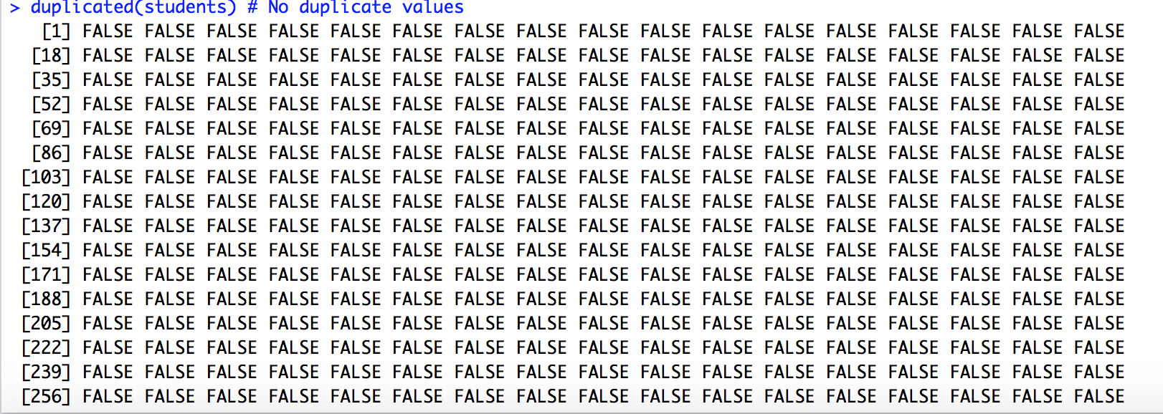

##############################################################

**handling missing values in dataset**

###############################################################

**# No missing values**

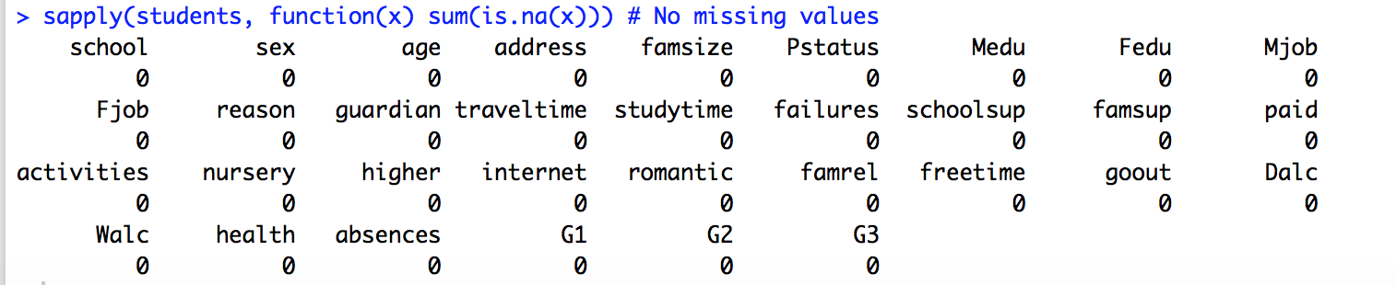

###############################################################

**Outliers Detection**

###############################################################

**# Outlier for Age variable**



There are two outliers which lie at the point 22 and 22. Hence, Student age variable has 2 outliers.

**# Outlier for Absences variable**



There are many outliers for Student Absences variable.

**Patterns and trends - Frequency Distribution**

**# plots based on Gender: We can see that the number of female students are greater than the number of male students**



**# plots based on Address: We can observe that many students belong from Urban when compared to rural.**



**# plots based on Parents staying together or apart: Below plot gives us information about family cohabitation status based on the gender**



**# plots based on higher education: Below plot show the number of students who are either interested or not interested to pursue higher education**



**# plots based on Internet: Below plot shows the number of students who have internet access and those who don’t.**



**# plots based on Workday alcohol: This plot shows the workday alcohol consumption for students**



**# plots based on Weekend alcohol: This plot shows the weekend alcohol consumption for students**



**# plots based on Absences: This plot shows the number of absences for students**



**# Distribution of ages of students on weekday alcohol consumption: Below plot shows how many students consume alcohol age wise on workdays based on the levels of consumption (1-very low, 2-low, 3-medium, 4-high 5- very high)**



**# Distribution of ages of students on weekend alcohol consumption: Below plot shows how many students consume alcohol age wise on weekends based on the levels of consumption (1-very low, 2-low, 3-medium, 4-high 5- very high)**



**# Distribution of test score (G3) on male and female students**



**#================================================================**

**Pattern 1 - Daily alcohol consumption and students grades**

**Pattern 2 - Weekend alcohol consumption and students grades**

Observation – We can observe that as the level of alcohol consumption increases, the grades tend to decrease as seen in below graphs

**#================================================================**

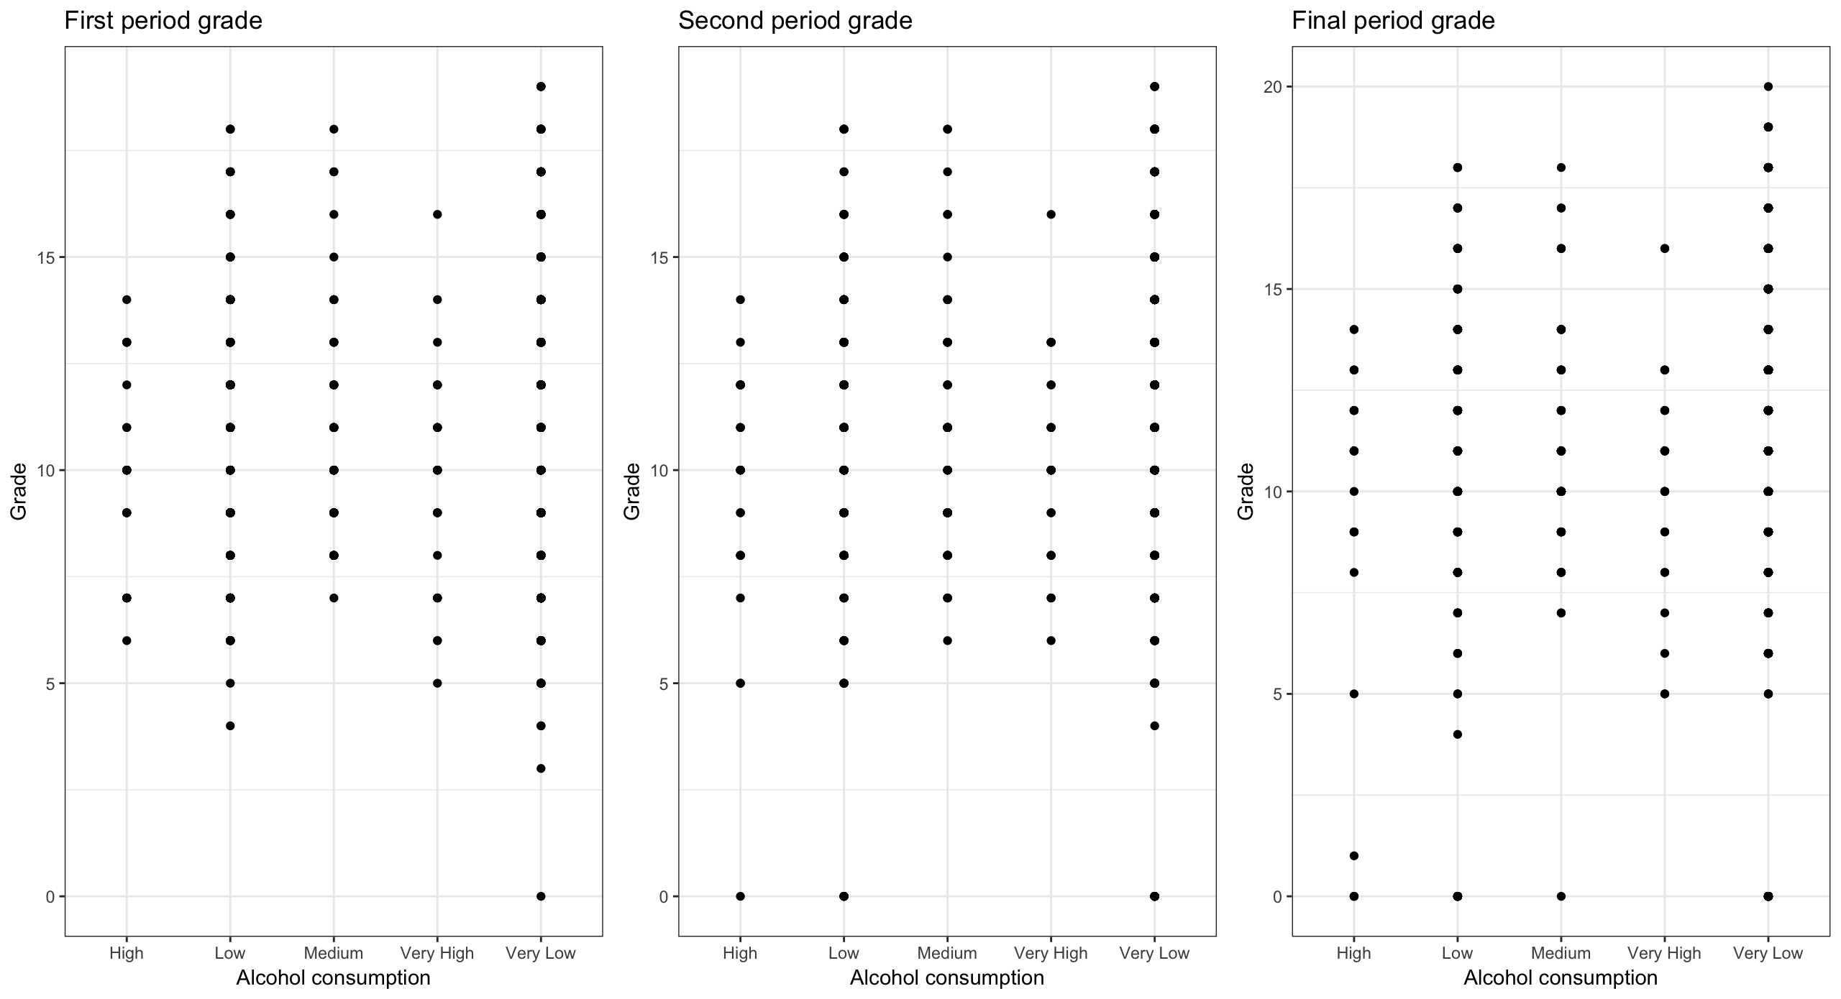

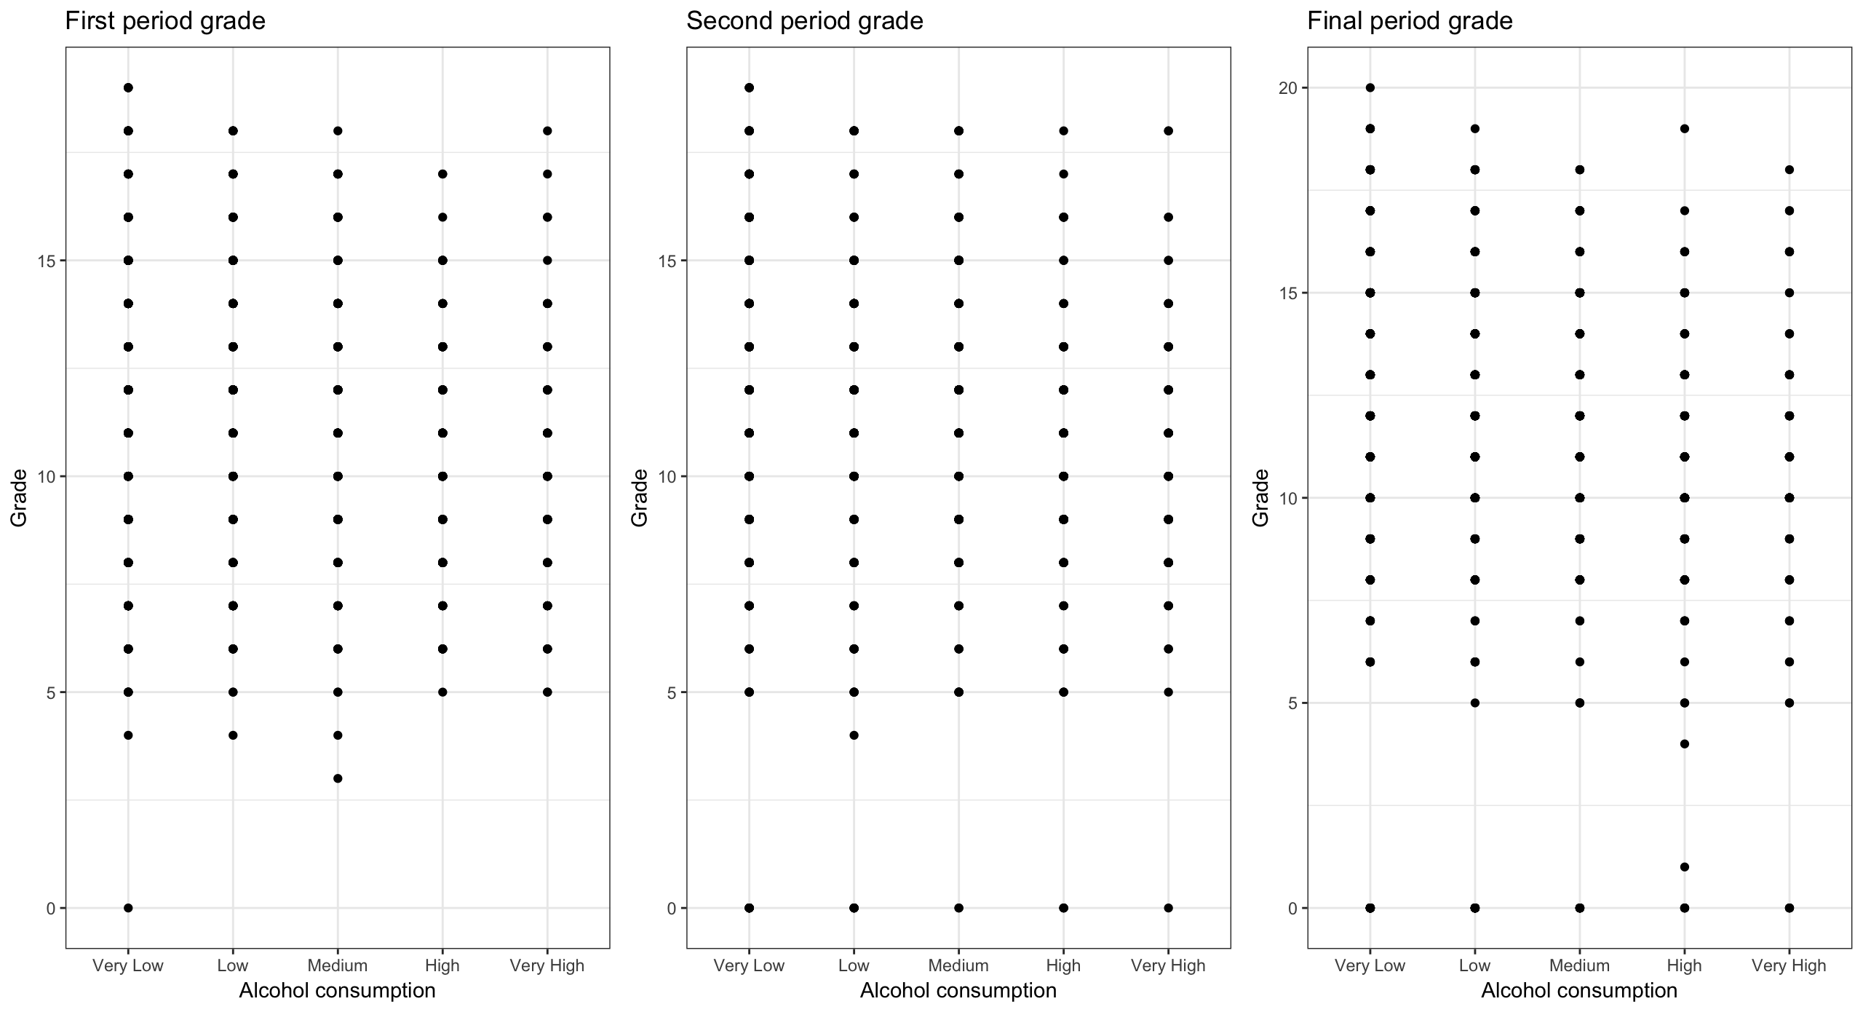

**#================================================================**

**Pattern - Distribution of First, Second & Third Period Grades**

**on Number of Students**

**#================================================================**



**#================================================================**

**Pattern - Weekend alcohol consumption of males and females and**

**their effects on G1, G2 and G3 grades**

Below plots show the weekend alcohol consumption for males and females based on ### individual point grades

**#================================================================**



Above plots show the weekend alcohol consumption for males and females based on individual point grades. We can see that as the alcohol consumption increases, the grades tend to decrease.

**#================================================================**

**Pattern - Daily alcohol consumption of males and females and**

**their effects on G1, G2 and G3 grades**

Below plots show the workday alcohol consumption for males and females based on ### individual point grades

**#================================================================**



Above plots show the workday alcohol consumption for males and females based on individual point grades. We can observe that the male students consume high alcohol and, we can see that as the alcohol consumption increases, the grades tend to decrease.

**#================================================================**

**Subset-1: Does high alcohol consumption affect the health condition?**

**#================================================================**



**# We can observe that the median grades become lower as the workday alcohol consumption increases.**

**# Only 8 out of 52 students who consume alcohol have bad health.**

**#================================================================**

**Subset-2: How many Students with high alcohol consumption have good**

**family relation?**

**#================================================================**

# 38 out of 52 students who have high alcohol consumption

maintains a good family relationship.

**#================================================================**

**Subset-3: How many Students with high daily alcohol consumption**

**also has high weekend alcohol consumption?**

**#================================================================**

# Here, we can observe that 42 out of 52 students who have high

weekday consumption also has high weekend consumption levels.

**#================================================================**

Subsets (2-Sample t-test)

**Subset-4: How many Students have less than 10 absences and more than 10 absences?**

**#================================================================**

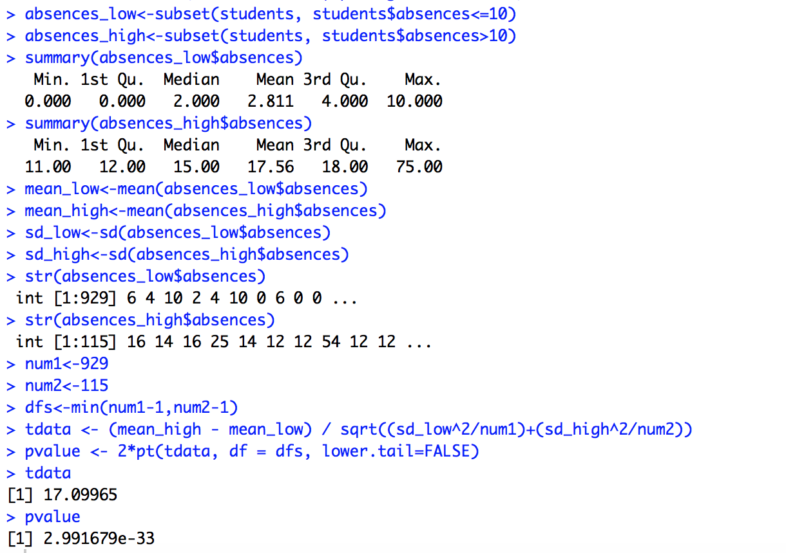

**# Performing 2-sample t-test to test the hypothesis**

Let's consider the hypothesis as below:

H0: mean_low = mean_high ; H1 : mean_low != mean_high

Here from tdata we get p value as 2.991679e-33 which is very low. Therefore, we have

extremely strong evidence to reject our null hypothesis(H0).

**#================================================================**

**Subset-5: Effect on grades by Mothers and Fathers education?**

**#================================================================**

**# Mother's education and Average grades**

Here x- axis represents the average grades, y-axis the count, and on the right-side the number 0,1,2,3,4 represents the level of education

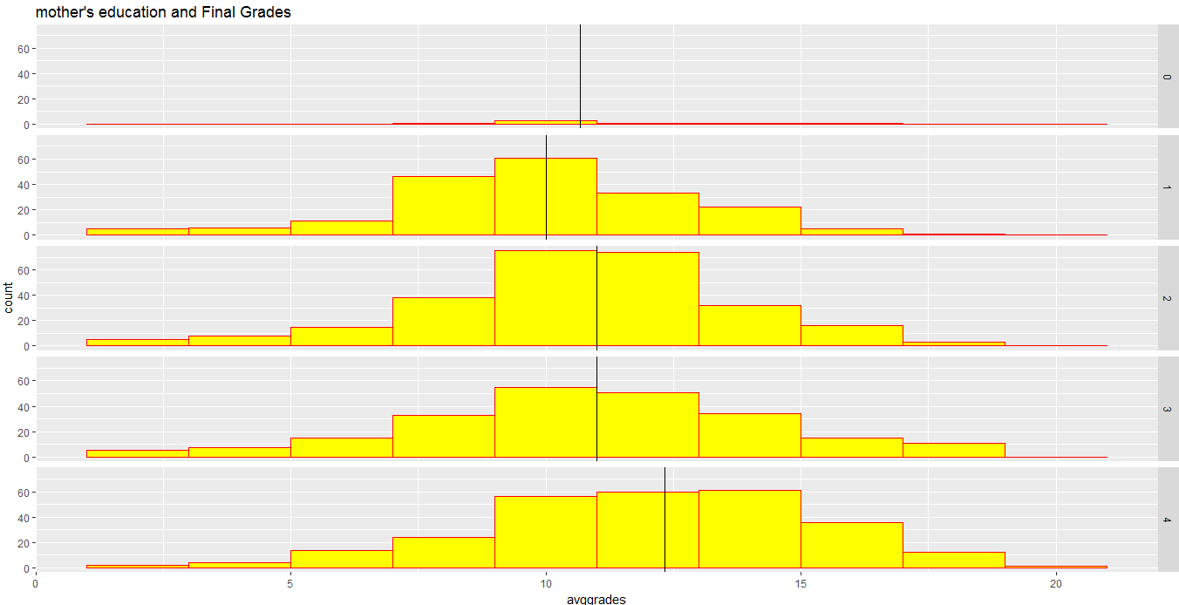

**# Father's education and Average grades**

Here x- axis represents the average grades, y-axis the count, and on the right-side the number 0,1,2,3,4 represents the level of education

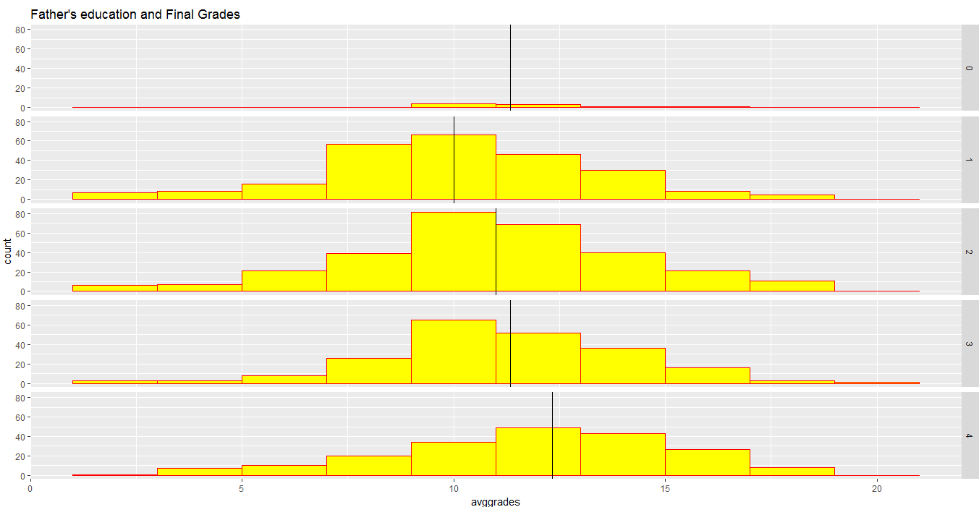

**# Observation:**

* As the mother's and father's level of education increases, the median average grade also increases.
* We can conclude that mother's and father's education level is certainly a factor for scoring good grades

**# Let’s see if having romantic relationship will affect average grades**

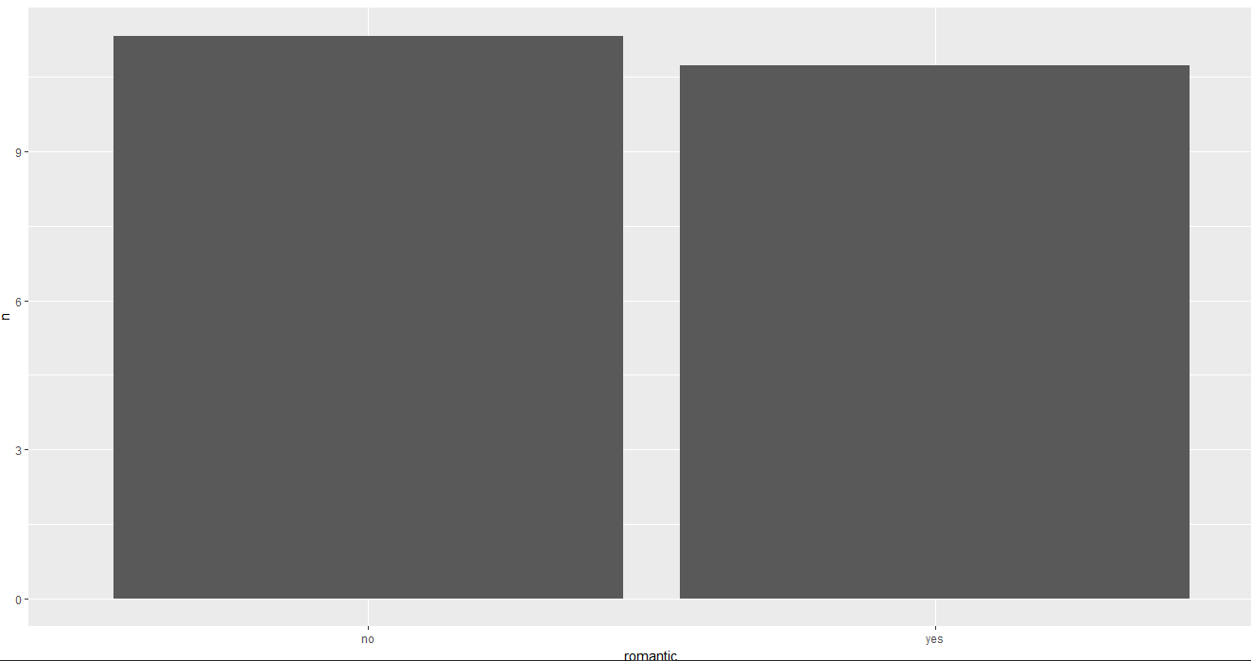

# As per the graph, the mean final grade (average grade) for those who were **not** in a relationship is greater than those who were in a relationship.

**# Now let's see how are these scores distributed**

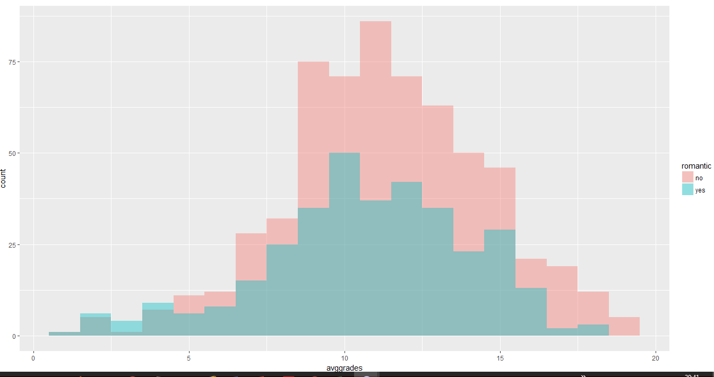

**# Observation:** We can see from the distribution that Students who were not in relationships scored higher grades more frequently than those students who were in relationships.

**#================================================================**

**Boxplot of Average subject grades grouped by the levels of daily alcohol consumption**

**#================================================================**

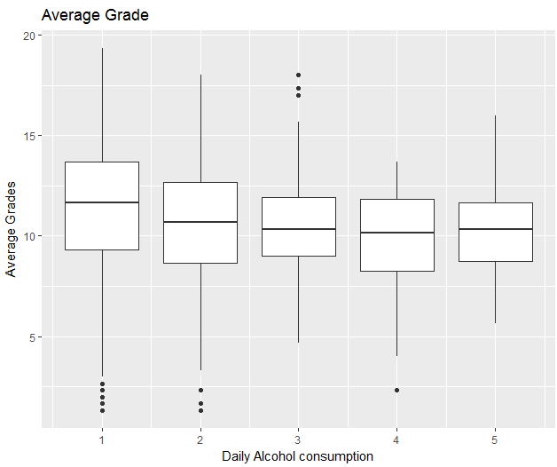

* We can observe the median average grade is higher among those students who had low levels of daily alcohol consumption, but the median grade of students with medium, high and very high levels of daily alcohol consumption very similar.
* Hence, we will do a multiple linear regression and build a regression tree of average grades on variables.

**#================================================================**

**Linear Multiple regression**

**#================================================================**

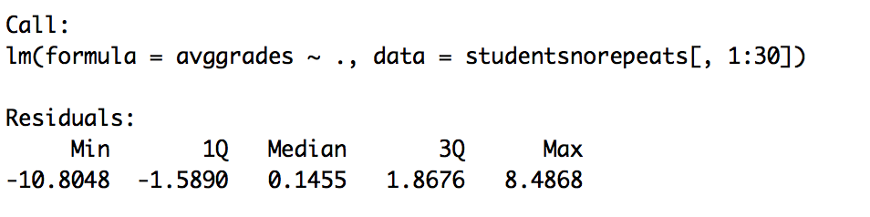

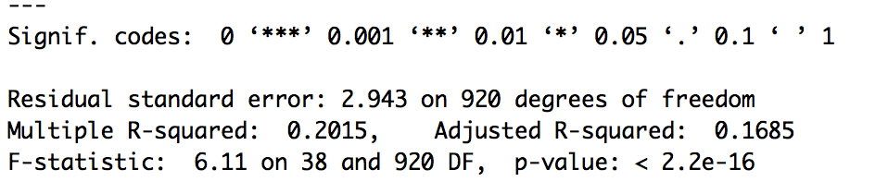

Here the adjusted r-squared value is **0.17** which is **very low**, which implies that only 17% of variation in the average grades is explained by everything else, so let’s see which other variables have a stronger impact on average grades.

**#================================================================**

**Regression Tree**

**#================================================================**

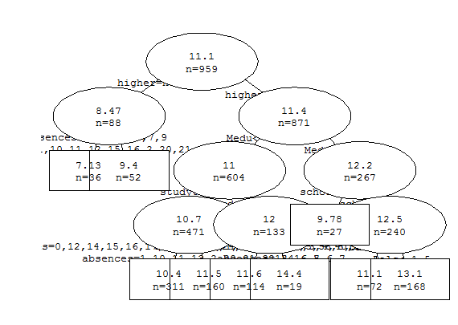

* As per the above regression tree analysis, one variable which has significant impact is "higher " which indicates whether the student wants to pursue higher education or no.
* Most students want to pursue higher education which is evident from their average grade which is (11.4 out of 20) and this average is higher than the students average (8.47 out of 20) who do not want to pursue higher education. The regression tree analysis also specfies that mother's education is another feature which can have impact on average grades as well.

# Now let’s evaluate the predictive performance of two models we are normalizing the mean squared error of two models.

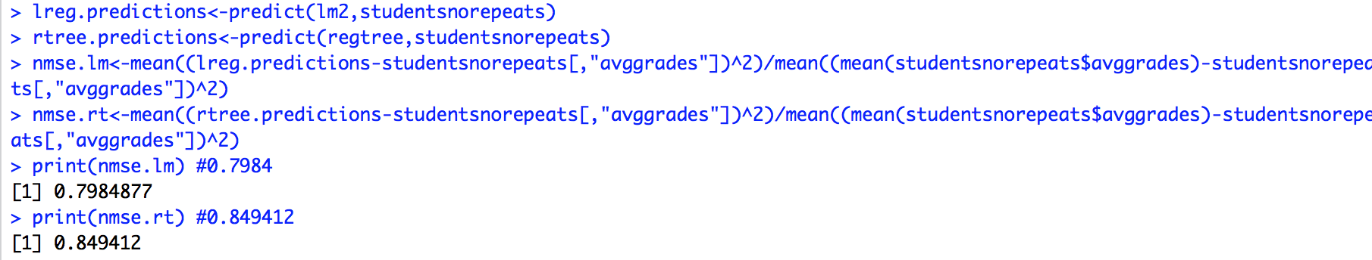

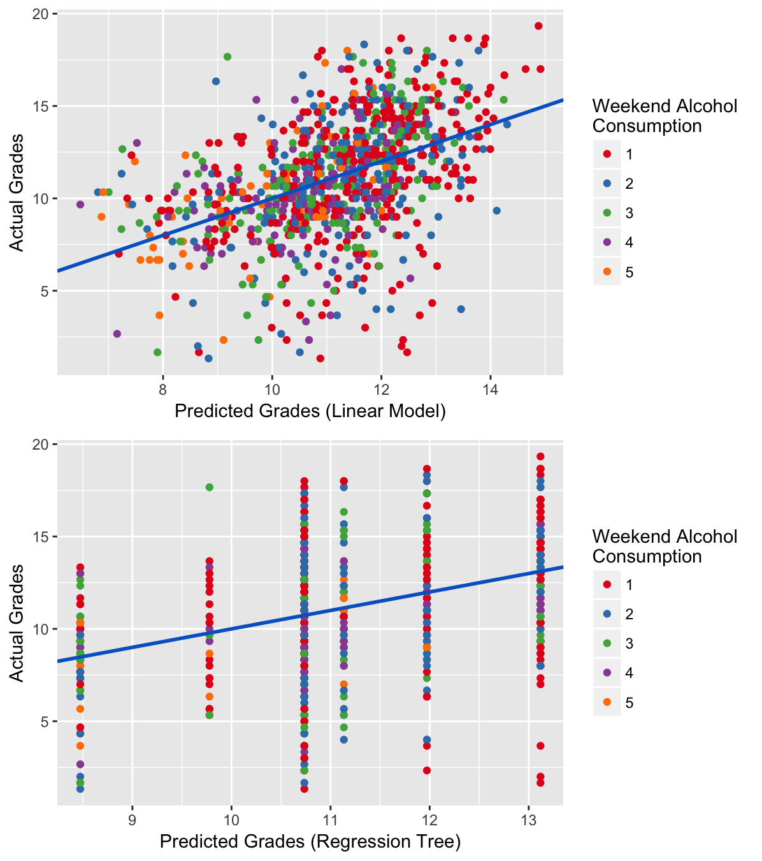

**Observation**:

* In the above graphs, horizontal axes represent predicted grades and vertical axes represent actual grades.
* For the model to be accurate, the predicted grades should be equal to actual grades and the scatter points should be inline along the 45-degree line (blue line).
* But, that not the case here and both the models do not help in accurately predicting student average grades so, we now process to use random forest and find out if it helps in accurately perdition.



**Observation**:

* We can see that the normalized mean standard error of the random forest is 0.2016583 which is very much lower than the linear and regression tree models.

# To validate this, lets plot the error plot of the random forest to compare it with the error plots of linear and regression models.

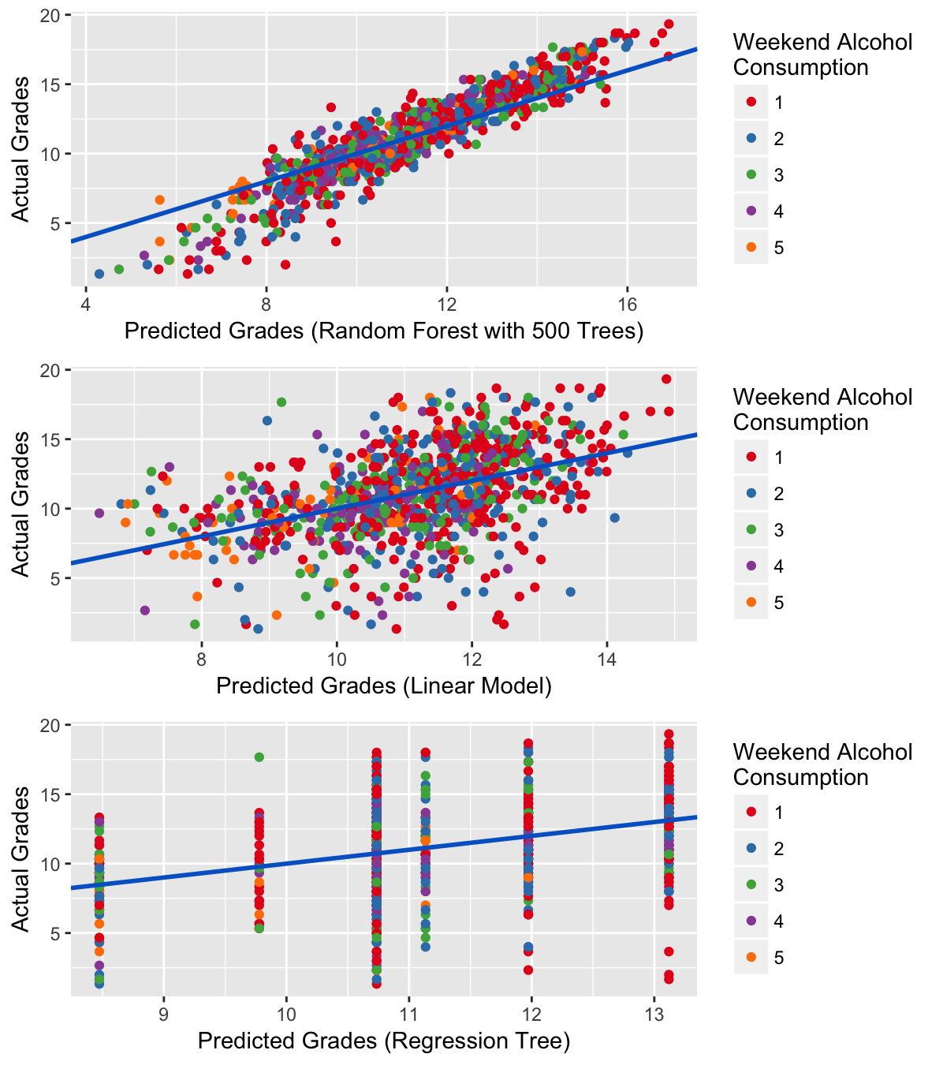

**Observation**:

* From the graph of error plots, we can say that random forest seems to be much better predictor of average grades than the linear or regression model.

# Let’s plot the graph to check which variable’s most impact the student grades as measured by random forest with 500 trees

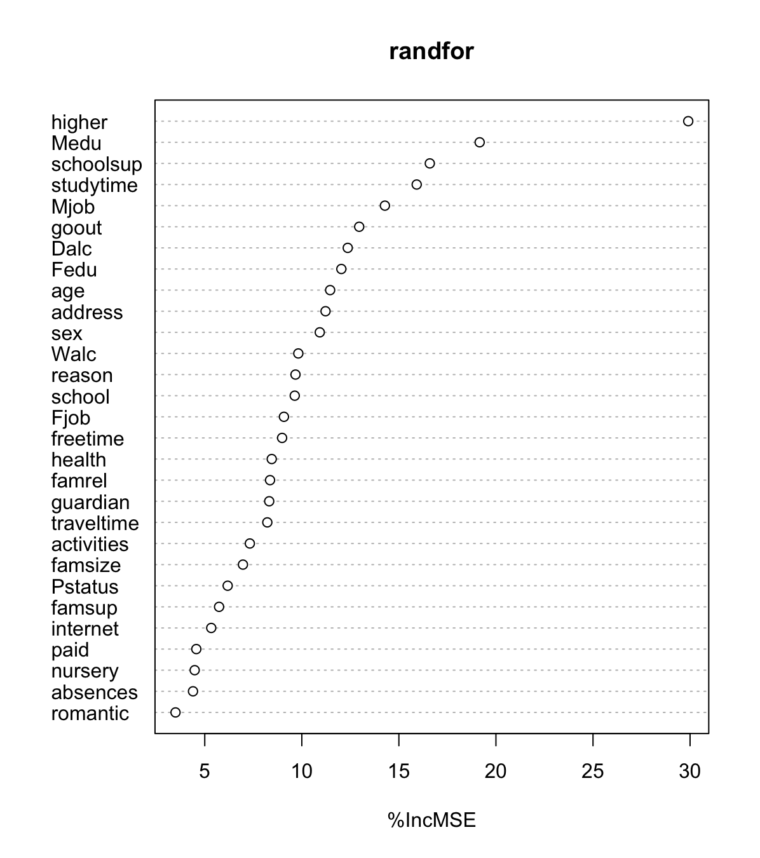

**Observation**:

The top 2 most important variables that impact student average grades are:

1. **higher**- wants to take higher education (binary: yes or no)
2. **Medu** - mother's education (numeric: 0 - none, 1 - primary education (4th grade), 2 – 5th to 9th grade, 3 - secondary education or 4 – higher education)

These results imply that both weekday and weekend alcohol consumption are important predictors of student average grades. Removing either of these two variables will increase the MSE (mean squared error) of predictions by between 10-20%.

As a conclusion, the impact of the most important 2 variables, "higher" and "Medu," on average student grade is as follows:

* **higher**: willingness to pursue higher education increases average predicted grade from 9.42 to 11.25. Thus, motivate your kids to pursue higher education is the best thing you can do to improve their grades in school!
* **Medu**: increase in mother's education from none to more than secondary education increases predicted average grade from 10.8 to 11.5. Thus, advice to future parents (especially fathers): If you want your future children do well in school marry someone educated.

**Data Preparation Phase**

**Data Cleansing**

Removing Anomalous Data– There are no anomalous data in our data set.

Removing Missing Values – There are no missing values in our data set.

Removing outliers in Absences



Before Normalization



After Normalization

Removing outliers in Age



Before Normalization



After Normalization

**#================================================================**

**New Variable – avggrades – mean of G1, G2 and G3 grades**

create a new variable to hold the category of the record (HIGH, MEDIUM, LOW)

**#================================================================**

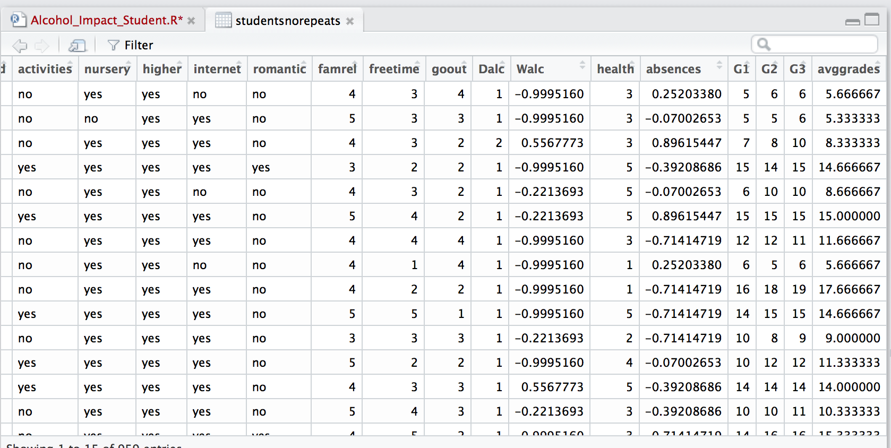

**#================================================================**

**Binning using k-means clustering**

create a new variable to hold the category of the record (HIGH, MEDIUM, LOW)

**#================================================================**

**K-Means Clustering**

***Parameters Used: -***

* avggrades – average grades of G1, G1 and G3
* Walc – Weekly Alcohol Consumption
* Dalc – Daily Alcohol Consumption

The records in the dataset were binned into three categories using “k means clustering”. 3 clusters are created using the algorithm. From cluster analysis, we can find which grades falls into which bin.

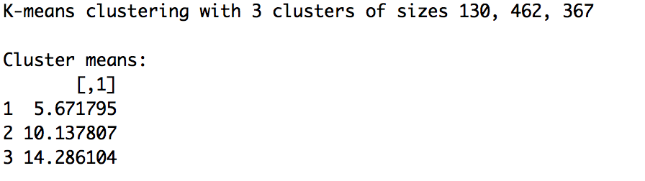

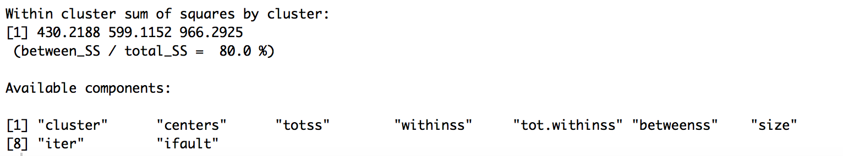

3 bins are created:

**1** – low, **2** - medium and **3**-high grades.

Students grades came under the same category. It can be visualized by following plot:



#=====================================================================

# **Data Transformation**

# We have many variables which are numerical which are stored as categorical,

# let’s transform those variables

# so that the numerical variables aren’t treated as continuous variables'

#=====================================================================

